Investigation 14B: Atmospheric Refraction

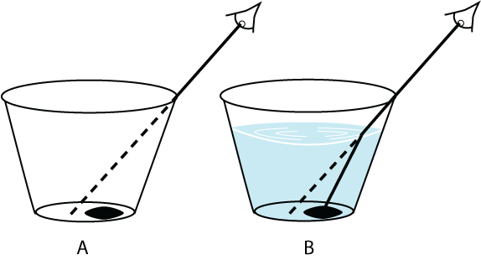

1. "Figure 2 shows that the atmospheric refraction of light ________ as the solar altitude decreases (approaches the horizon)."
- increases
- decreases

2. "The maximum amount of atmospheric refraction of a solar ray is ________ when the Sun is on the horizon (solar altitude of 0 degrees)."
- less than one degree
- several degrees

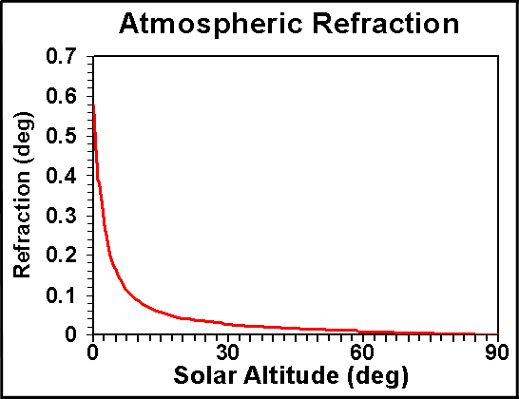

3. "At sunset (or sunrise) with the Sun right on the horizon, the refraction of a Sun’s ray is 0.58 degrees. The mean angular diameter of the Sun’s visible disk is approximately 0.53 degrees. (Angular diameter is the angle formed at the observer’s eye by two lines drawn from opposite edges of the Sun’s disk.) Thus, the Sun’s position may be distorted by the bending of its rays by slightly more than its own diameter. When very near the horizon, the apparent Sun (the one we see) is approximately ________ degree(s) higher than it would be in the absence of atmospheric refraction. In other words, the Sun can actually be below the horizon when the bent rays give its appearance as being fully above the horizon!"
- 0.5
- 1.5
- 3

4. "A spherical Earth would be half sunlit at all latitudes on an equinox, except at the poles. Without an atmosphere, the period of daylight at any latitude on Earth (except at the poles) would be ________ hours and 0 minutes on that first day of spring or fall."
- 11
- 12
- 13

5. "As shown in Figure 2 of Investigation 3B, the daily path of the Sun through the sky varies at different latitudes on Earth. At the equator, the daily path of the Sun is always perpendicular to the horizon. As the latitude increases, the angle between the Sun’s path through the daytime sky and the horizon ________ until it is nearly parallel to the local horizon at the North and South Poles. Thus, the time it takes the Sun to change solar altitude (measured vertically from the horizon) while actually moving steadily along its inclined path will increase with increasing latitude."
- increases
- decreases

Table 1: Sunrise/Sunset Times - 21 March
City Latitude Sunrise Sunset
Quito 0.0° N 6:16 a.m. 6:22 p.m.
Gettysburg 45.0° N 6:41 6:54
Thule 76.5° N 4:55 5:33

6. "Quito’s hours and minutes of daylight: 12 hrs ________ min."
- 0
- 6
- 13
- 38
- 46

7. "Gettysburg’s hours and minutes of daylight: 12 hrs ________ min."
- 0
- 6
- 13
- 38
- 46

8. "Thule’s hours and minutes of daylight: 12 hrs ________ min."
- 0
- 6
- 13
- 38
- 46

9. "Quito’s minutes of daylight beyond 12 hours: ________ min."
- 0
- 6
- 13
- 38
- 46

10. "Gettysburg’s minutes of daylight beyond 12 hours: ________ min."
- 0
- 6
- 13
- 38
- 46

11. "Thule’s minutes of daylight beyond 12 hours: ________ min."
- 0
- 6
- 13
- 38
- 46

12. "The number of minutes of daylight beyond twelve hours on 21 March ________ with increasing latitude. The additional daylight time is due to the combination of two factors, the orientation of the Sun’s path and atmospheric refraction. The smaller the angle of the Sun’s path to the horizon, the greater the effect of refraction in lengthening the period of daylight."
- increases
- decreases

Applications

13. "The sunrise/sunset data appearing in Table 1 were taken from tables similar to the example shown in Table 2 of this investigation. Table 2 displays “Rise and Set for the Sun for 2016” for Selawik, Alaska, located at 66.6 degrees N. The sunrise and sunset times are given in local Standard Time on a 24-hour clock; for example, 1842 means 6:42 p.m., local Standard Time. The table indicates that on 20 March 2016 (date of the 2016 spring equinox) the Sun rose at 07:37 and set at ________, local Standard Time."
- 17:42
- 18:47
- 19:26
- 19:59

14. "Selawik’s period of sunlight on 20 March was 12 hours and ________ minutes."
- 0
- 7
- 14
- 22

15. "The number of minutes of daylight beyond 12 hours on 20 March at Selawik ________ the pattern of change in the length of daylight with increasing latitude shown in Table 1. [The one day difference in the dates of Table 1 and 2 data can be ignored in the comparison.]"
- fits
- does not fit

16. "However, according to Table 2, the longest continuous daylight period (****) at Selawik was ________ days in length."
- 1
- 14
- 21
- 32
- 36

17. "According to the table, the shortest period of daylight at Selawik occurs on or near the first day of winter in late December and is two hours and ________ minutes long."
- 0
- 7
- 13
- 22

18. "Atmospheric refraction is the primary cause of the differences between the periods of daylight that might be expected with straight rays of sunlight striking the Earth’s surface and the daylight periods calculated by the U.S. Naval Observatory. It was shown earlier in this investigation that, when near the horizon, the apparent Sun (the one we see) is ________ than it would be if there were no atmospheric refraction. Thus, over the period of a year, the Sun at the Arctic Circle stays continuously above the horizon for considerably more than one day and it never actually goes below the horizon for a continuous 24-hour day."
- higher
- lower

